I need to Hack potter...
Description
I captured professor quirrell network activity though capturing the packets. Help me to solve it.

--I downloaded the pcap file and open it with wireshark and I found some 20 packets in it
After I export all the packets with filter http, when we done this it shows only the files
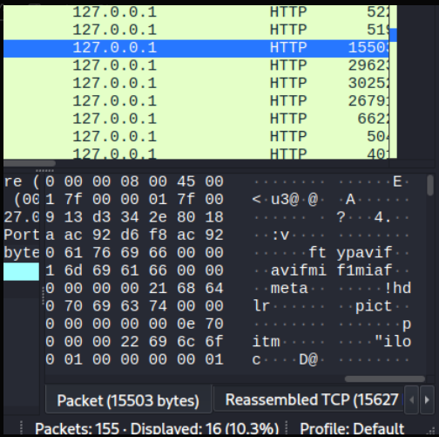

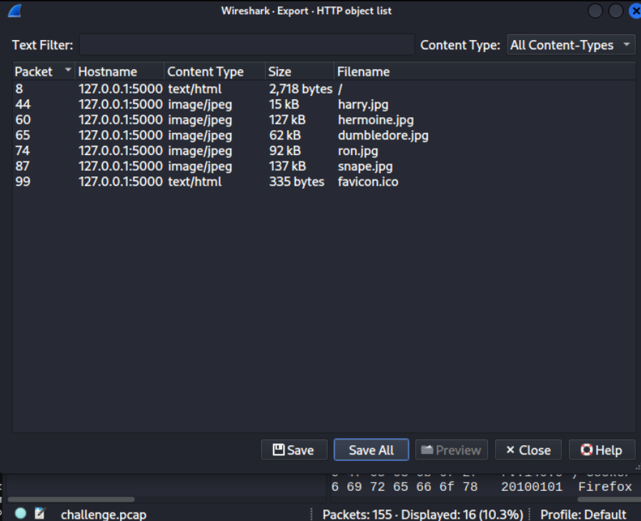

--I manually checked all files with exiftool for comments lastly I got comment in ron
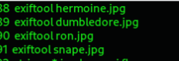
History
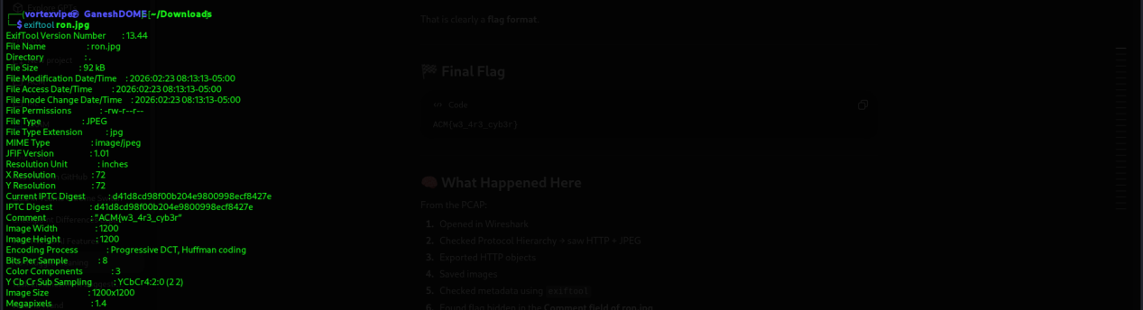

--I thought this is the final flag but when I was submitting it, it shows error so I have gone through another time but no use

--After I have take help from the author and he said me that there is another part go and search hexadecimal or a hex editor tool, I used ghex and found the 2 part

